**VLOOKUP + ERROR DATA CLEANING**

**=IFERROR(VLOOKUP(N2,'DATA MATCHING'!$E$2:$L$86,8,FALSE)&"","")**

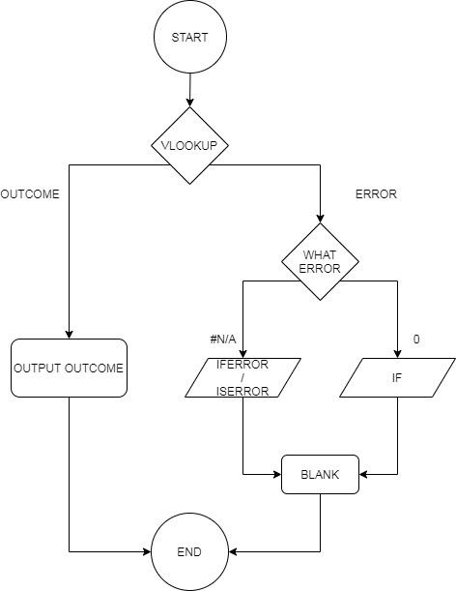

**CHECKING DATE IS WITHIN 6 YEARS OR NOT**

**=IF(OR(AND(ISNUMBER(A2)=TRUE,A2>201400),AND(ISNUMBER(B2)=TRUE,B2>201400),AND(ISNUMBER(C2)=TRUE,C2>201400),AND(ISNUMBER(D2)=TRUE,D2>201400),AND(ISNUMBER(E2)=TRUE,E2>201400)),"YES","NO")**

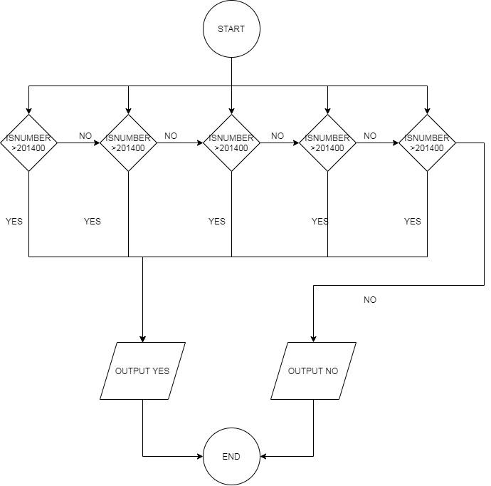

**CHECKING IF OLD DATABASE HAVE OR NOT**

**=IFERROR(IF(MATCH(RAW_CCCAI!$A2,'2019_CCCAI'!$C$2:$C$94,0)<>0,"OLD"),"NEW")**

